DATA ACTIVITY 4 – PLOTTING WITH R: COVID 19 IN INDIA

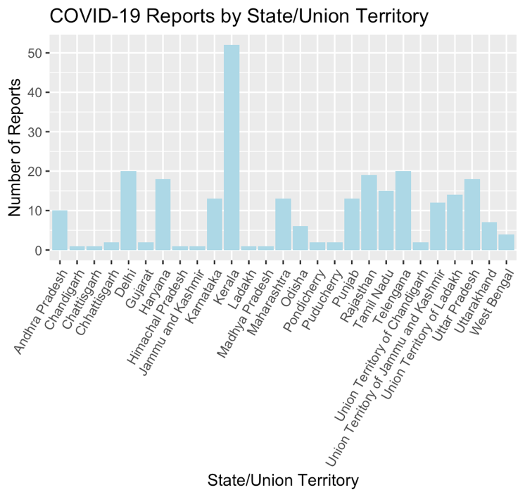
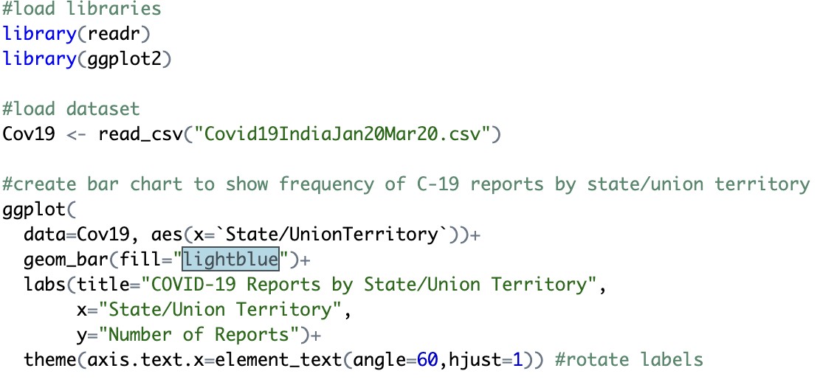
Task 4.1 - Create a bar chart showing the frequency of COVID-19 reports by state/union territory.

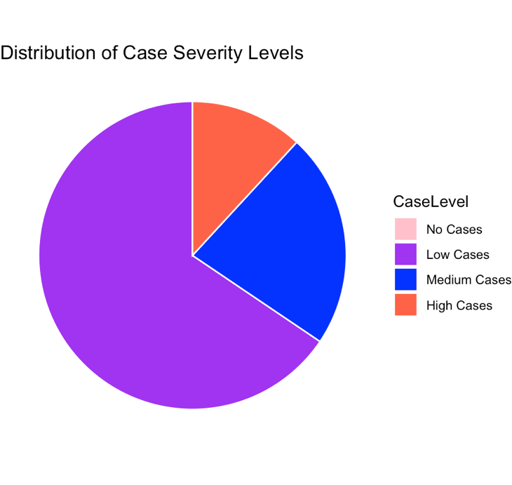
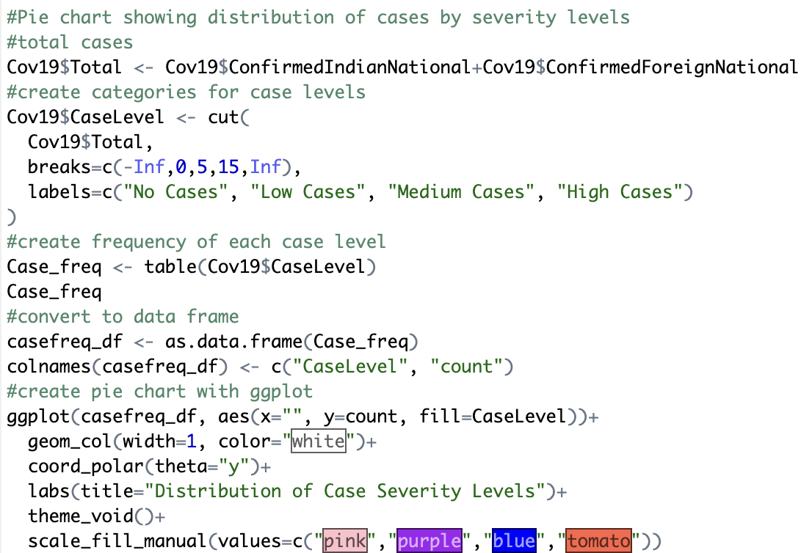
Task 4.2 - Using variables ConfirmedIndianNational and ConfirmedForeignNational, create a pie chart showing the distribution of case severity levels based on total confirmed cases.

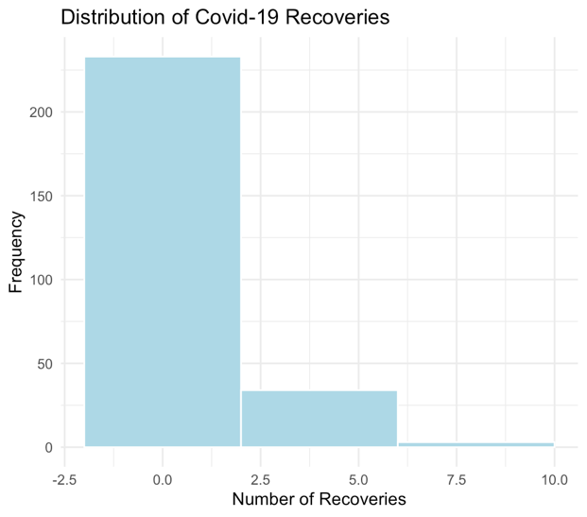
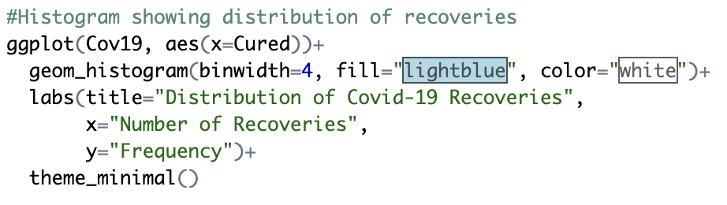
Task 4.3 - Create a histogram showing the distribution of recovery numbers

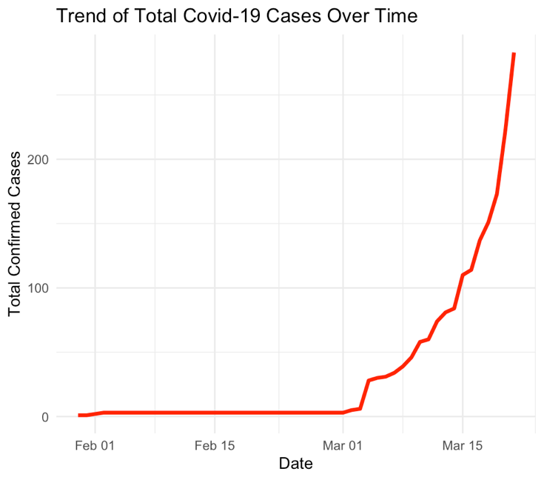
Task 4.4 - Create a line chart showing the trend of total cases over time
